URL VIDEO WEB FRAMEWORK APLIKASI MOBILE

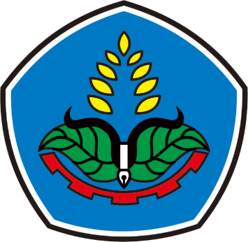

**SISTEM INFORMASI REPAIRME BERBASIS WEB DAN ANDROID**

**Oleh :**

Mohammad Arief Hidayatullah (E41182271)

Bagus Duwi Prasetiyo (E41181215)

Alvin (E41182112)

Ahmad Dandi Irawan (E41180087)

Taufik Hariyanto (E41182233)

**PROGRAM STUDI TEKNIK INFORMATIKA**

**JURUSAN TEKNOLOGI INFORMASI**

**POLITEKNIK NEGERI JEMBER**

**2020**

Link Video REPAIRME

Google Drive :

<https://drive.google.com/file/d/1yVHEn1miEVpQIg9A4npxo9RKo0f9idD0/view?usp=sharing>

Youtube :

[https://](https://kelompok1bws@prps-polibon.polije.com/)www.youtube.com/watch?v=eZ0XKPmQR6Y